George Smith

Lab 8

1.

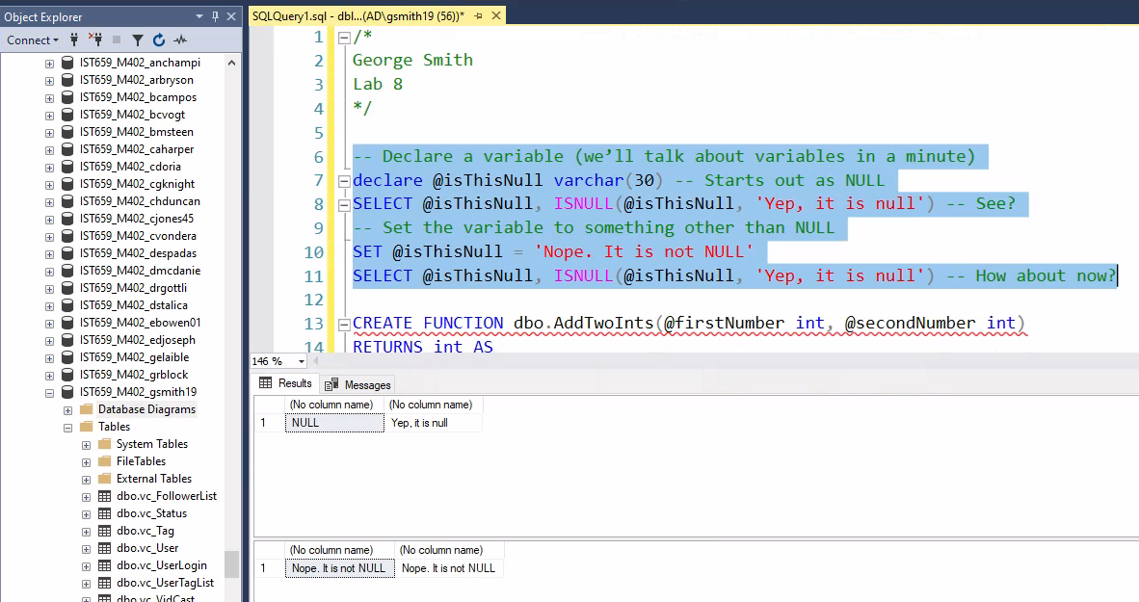

2.

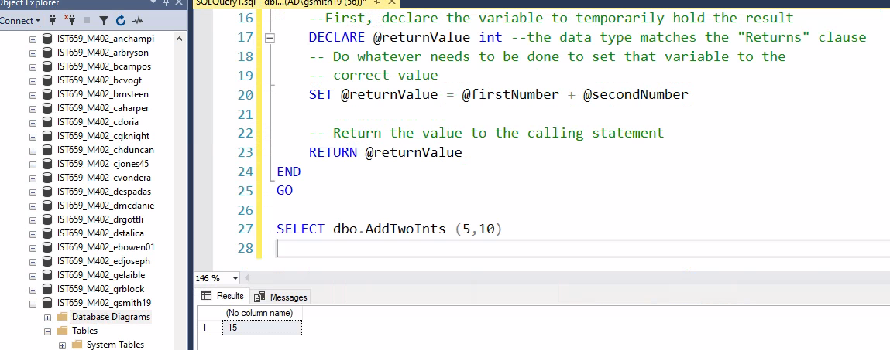

3.

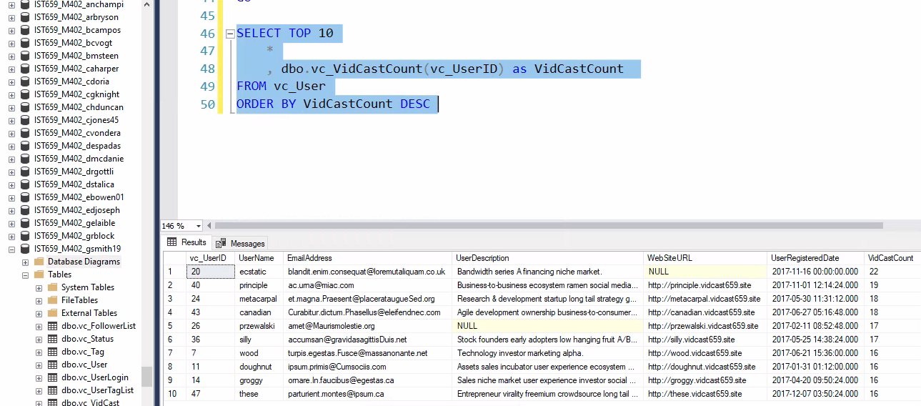

4.

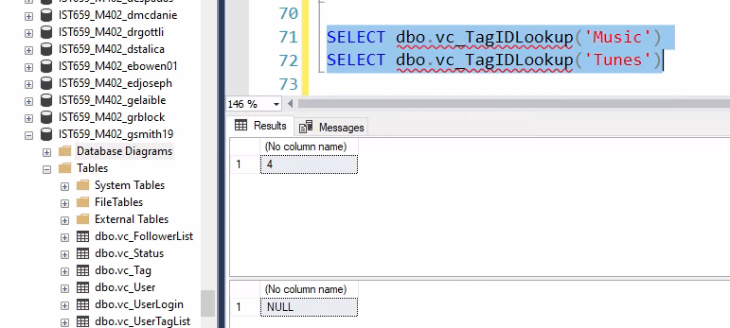

5. The above code is returning the amount of TagIDs where the TagText has either the parameter music of tunes. The null value shows that the parameter Tunes did not have any results.

6.

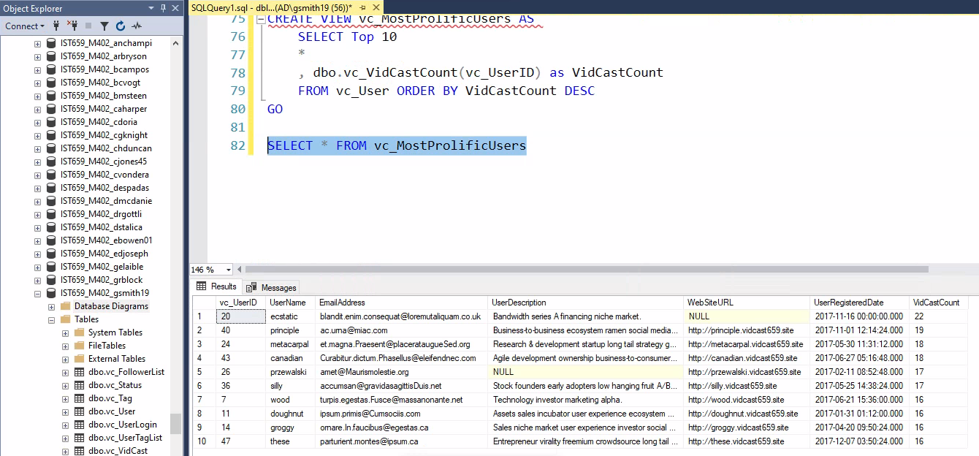

7.

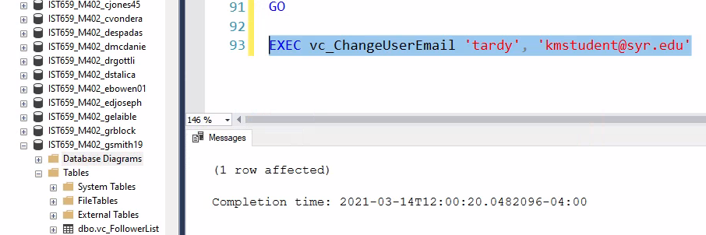

8. 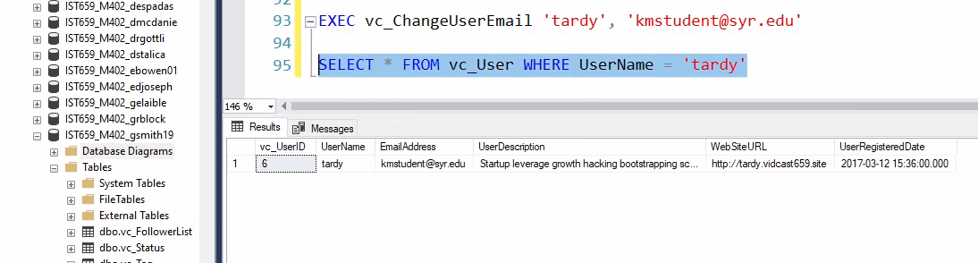

9. 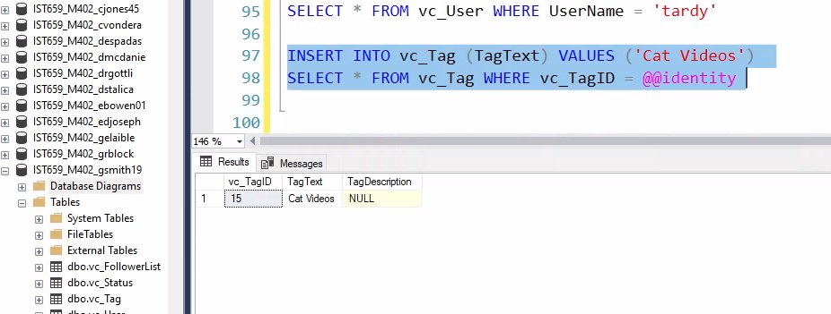

10.

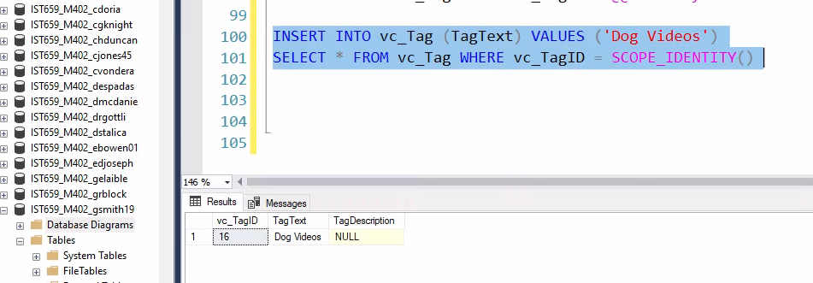

11.

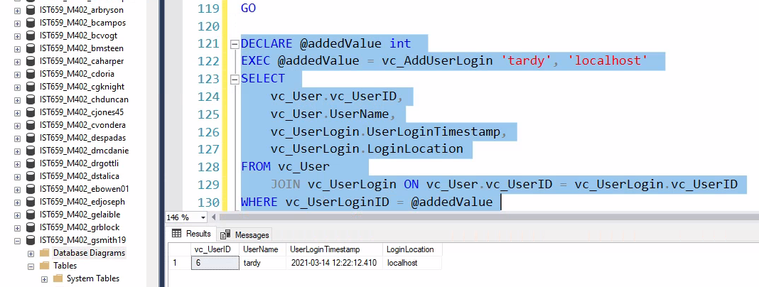

**Part 2**

1. 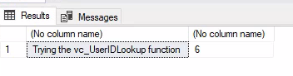
2. 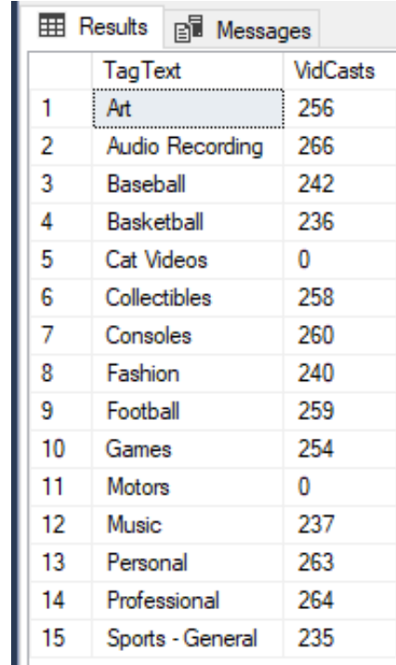
3. 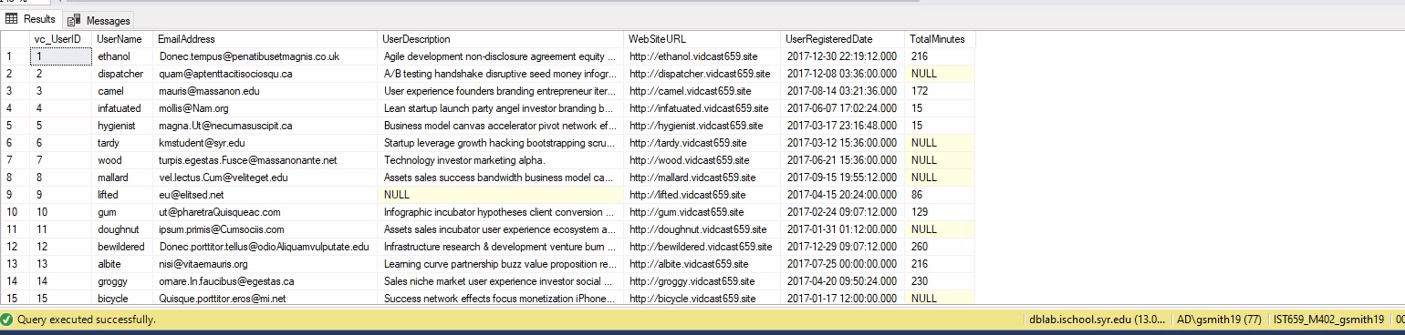
4. 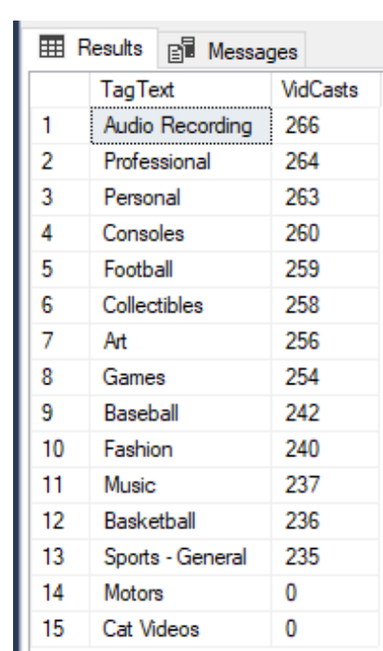
5. 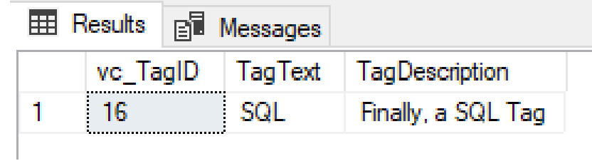
6. 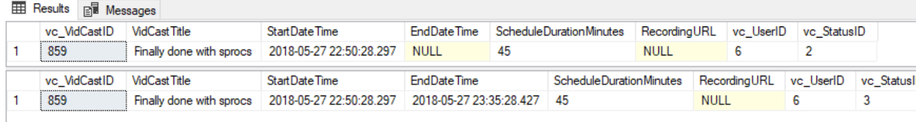

**SQL CODE:**

**/\***

**George Smith**

**Lab 8**

**\*/**

**-- Declare a variable (we’ll talk about variables in a minute)**

**declare @isThisNull varchar(30) -- Starts out as NULL**

**SELECT @isThisNull, ISNULL(@isThisNull, 'Yep, it is null') -- See?**

**-- Set the variable to something other than NULL**

**SET @isThisNull = 'Nope. It is not NULL'**

**SELECT @isThisNull, ISNULL(@isThisNull, 'Yep, it is null') -- How about now?**

**CREATE FUNCTION dbo.AddTwoInts(@firstNumber int, @secondNumber int)**

**RETURNS int AS**

**BEGIN**

**--First, declare the variable to temporarily hold the result**

**DECLARE @returnValue int --the data type matches the "Returns" clause**

**-- Do whatever needs to be done to set that variable to the**

**-- correct value**

**SET @returnValue = @firstNumber + @secondNumber**

**-- Return the value to the calling statement**

**RETURN @returnValue**

**END**

**GO**

**SELECT dbo.AddTwoInts (5,10)**

**-- Function to count the Vidcasts made by a given User**

**CREATE FUNCTION dbo.vc_VidCastCount (@userID int)**

**RETURNS int AS -- COUNT () is an integer value, so return it as an int**

**BEGIN**

**DECLARE @returnValue int -- matches the function's return type**

**/\***

**Get the count of the VidCasts for the provided userID and assign that value to @returnValue. Note that we use the @userID parameter in the WHERE calue to limit our count to that User's Vidcast records.**

**\*/**

**SELECT @returnValue = COUNT (vc_UserID) FROM vc_VidCast**

**WHERE vc_VidCast.vc_UserID = @userID**

**-- Return @returnValue to the calling code.**

**RETURN @returnValue**

**END**

**GO**

**SELECT TOP 10**

**\***

**, dbo.vc_VidCastCount(vc_UserID) as VidCastCount**

**FROM vc_User**

**ORDER BY VidCastCount DESC**

**GO**

**--Function to retrieve the vc_TagID for a given tag's text**

**CREATE FUNCTION dbo.vc_TagIDLookup(@tagText varchar (20))**

**RETURNS int AS -- vc_TagID is an int, so we'll match that**

**BEGIN**

**DECLARE @returnvalue int --Matches the funtion's return type**

**/\***

**Get the vc_TagID of the vc_Tag record whose TagText matches the parameter and assign that value to @returnValue.**

**\*/**

**SELECT @returnValue = vc_TagID FROM vc_Tag**

**Where TagText = @tagText**

**--Send the vc_TagID back to the caller**

**RETURN @returnValue**

**END**

**SELECT dbo.vc_TagIDLookup('Music')**

**SELECT dbo.vc_TagIDLookup('Tunes')**

**-- Create a view to retrieve the top 10 vc_Users and their VidCast counts**

**CREATE VIEW vc_MostProlificUsers AS**

**SELECT Top 10**

**\***

**, dbo.vc_VidCastCount(vc_UserID) as VidCastCount**

**FROM vc_User ORDER BY VidCastCount DESC**

**GO**

**SELECT * FROM vc_MostProlificUsers**

**--create a procedure**

**CREATE PROCEDURE vc_ChangeUserEmail (@userName varchar (20), @newEmail varchar(50))**

**AS**

**BEGIN**

**UPDATE vc_User Set EmailAddress = @newEmail**

**Where UserName = @userName**

**END**

**GO**

**EXEC vc_ChangeUserEmail 'tardy', 'kmstudent@syr.edu'**

**SELECT * FROM vc_User WHERE UserName = 'tardy'**

**INSERT INTO vc_Tag (TagText) VALUES ('Cat Videos')**

**SELECT * FROM vc_Tag WHERE vc_TagID = @@identity**

**INSERT INTO vc_Tag (TagText) VALUES ('Dog Videos')**

**SELECT * FROM vc_Tag WHERE vc_TagID = SCOPE_IDENTITY()**

**-- New Procedure**

**CREATE OR ALTER PROCEDURE vc_AddUserLogin (@userName varchar(20), @loginFrom varchar(50))**

**AS**

**BEGIN**

**DECLARE @userID int**

**SELECT @userID = vc_UserID FROM vc_User**

**WHERE UserName = @userName**

**INSERT INTO vc_UserLogin (vc_UserID, LoginLocation)**

**VALUES (@userID, @loginFrom)**

**RETURN SCOPE_IDENTITY()**

**END**

**GO**

**DECLARE @addedValue int**

**EXEC @addedValue = vc_AddUserLogin 'tardy', 'localhost'**

**SELECT**

**vc_User.vc_UserID,**

**vc_User.UserName,**

**vc_UserLogin.UserLoginTimestamp,**

**vc_UserLogin.LoginLocation**

**FROM vc_User**

**JOIN vc_UserLogin ON vc_User.vc_UserID = vc_UserLogin.vc_UserID**

**WHERE vc_UserLoginID = @addedValue**

**-- Part 2**

**-- create a function to retrieve a vc_UserID for a given user name**

**CREATE FUNCTION dbo.vc_UserIDLookup(@userName varchar(20))**

**RETURNS int AS**

**BEGIN**

**DECLARE @returnValue int**

**SELECT @returnValue = (vc_UserID) FROM vc_User**

**WHERE Username = @userName**

**RETURN @returnValue**

**END**

**GO**

**SELECT 'Trying the vc_UserIDLookup function' , dbo.vc_UserIDLookup('tardy')**

**-- statement**

**CREATE FUNCTION dbo.vc_TagVidCastCount (@VidCastID int)**

**RETURNS int AS**

**BEGIN**

**DECLARE @returnvalue int**

**SELECT @returnValue = COUNT (vc_VidCastID) FROM vc_VidCast**

**WHERE vc_Vidcast.vc_VidCastID = @VidCastID**

**RETURN @VidCastID**

**END**

**GO**

**SELECT**

**vc_Tag.TagText,**

**dbo.vc_TagVidCastCount(vc_Tag.vc_TagID) as VidCasts**

**FROM vc_tag**

**--Question 3**

**CREATE FUNCTION dbo.vc_VidCastDuration(@VidCastDuration int)**

**RETURNS int AS**

**BEGIN**

**DECLARE @returnValue int**

**SELECT @returnValue = DATEDIFF(n, StartDateTime, EndDateTime) FROM vc_VidCast**

**WHERE vc_VidCast.vc_UserID = @VidCastDuration**

**RETURN @returnValue**

**END**

**GO**

**SELECT**

**\***

**, dbo.vc_VidCastDuration(vc_UserID) as TotalMinutes**

**FROM vc_User**

**-- Create view**

**CREATE VIEW vc_TagReport AS**

**SELECT vc_Tag.TagText,**

**dbo.vc_TagVidCastCount(vc_Tag.vc_TagID) as VidCasts**

**FROM vc_Tag**

**ORDER BY VidCasts DESC**

**GO**

**SELECT * FROM vc_TagReport**

**-- Create a stored procedure**

**CREATE PROCEDURE vc_AddTag(@tagText varchar(20), @description varchar(100)=NULL)**

**AS**

**BEGIN**

**DECLARE @vc_TagID int**

**SELECT @vc_TagID = vc_TagID FROM vc_Tag**

**Where TagText = @tagText**

**INSERT INTO vc_Tag (vc_TagID, TagDescription)**

**VALUES (@vc_TagID, @description)**

**RETURN SCOPE_IDENTITY()**

**END**

**GO**

**DECLARE @newTagID int**

**EXEC @newTagID = vc_AddTag 'SQL', 'Finally, a SQL Tag'**

**SELECT * FROM vc_Tag where vc_TagID = @newTagID**

**CREATE PROCEDURE vc_FinishVidCast (@VidCastID int, @finished int )**

**AS**

**BEGIN**

**UPDATE vc_VidCast**

**set vc_StatusID=@finished**

**where vc_VidCastID = @VidCastID**

**end**

**go**

**DECLARE @newVC int**

**INSERT INTO vc_VidCast**

**(VidCastTitle, StartDateTime, ScheduleDurationMinutes, vc_UserID,**

**vc_StatusID)**

**VALUES (**

**'Finally done with sprocs'**

**, DATEADD(n, -45, GETDATE())**

**, 45**

**, (SELECT vc_UserID FROM vc_User WHERE UserName = 'tardy')**

**, (SELECT vc_StatusID FROM vc_Status WHERE StatusText='Started')**

**)**

**SET @newVC = SCOPE_IDENTITY()**

**SELECT * FROM vc_VidCast WHERE vc_VidCastID = @newVC**

**EXEC vc_FinishVidCast @newVC**

**SELECT * FROM vc_VidCast WHERE vc_VidCastID = @newVC**